Name: Student ID:

Lab Section: Date:

**Prelab**

1. Label the following counter diagrams as synchronous/asynchronous up/down, and negative/positive-edge triggered.

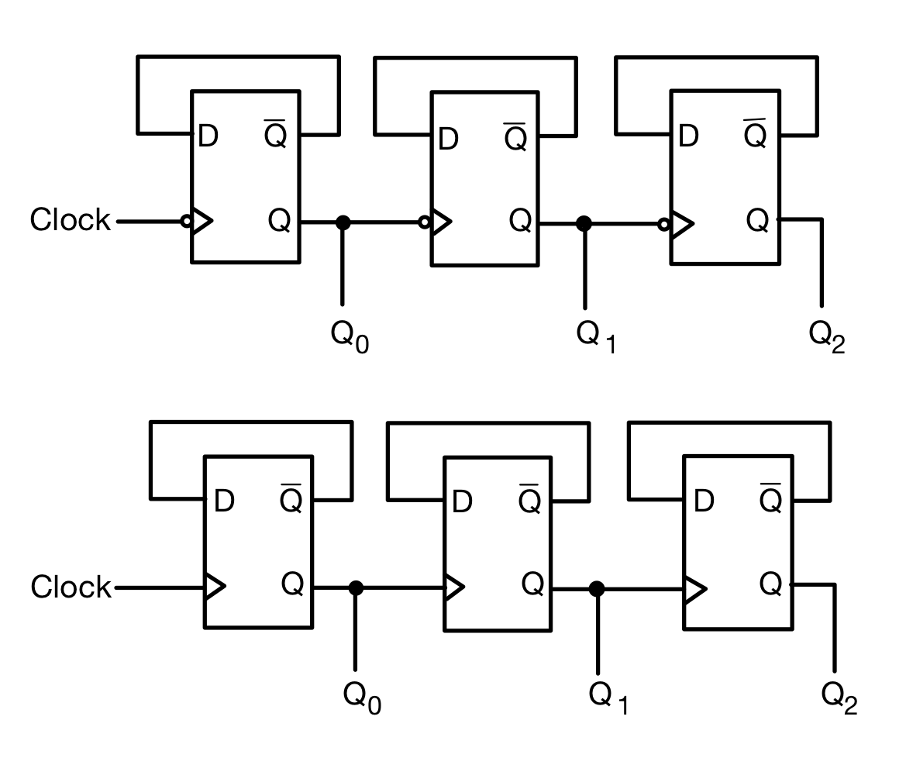

A: Positive-edge triggered DFF A: Negative-edge triggered DFF

_____________________________ _____________________________

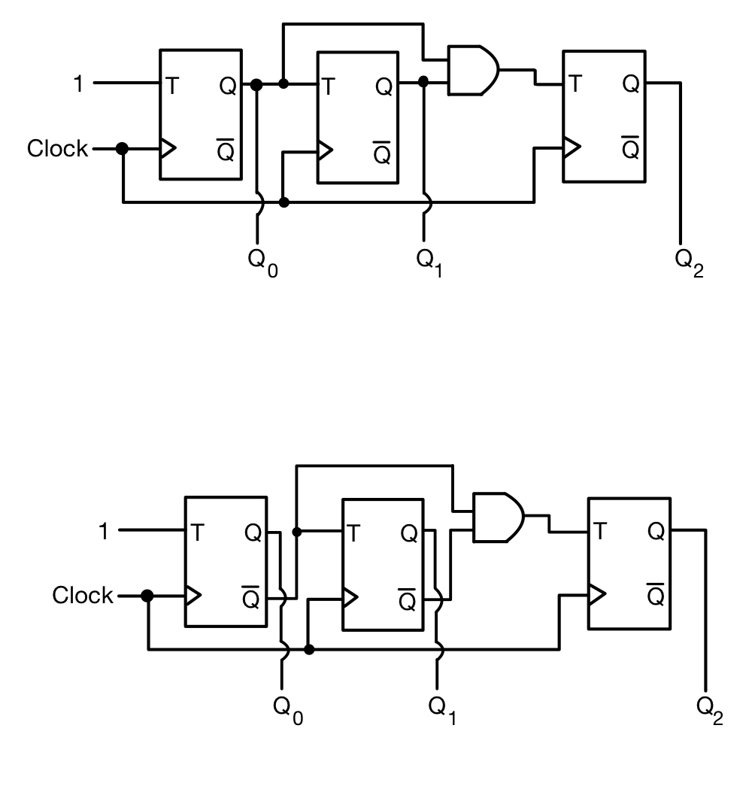

A: Asynchronous Up Counter A: Asynchronous Down Counter

_____________________________ _____________________________

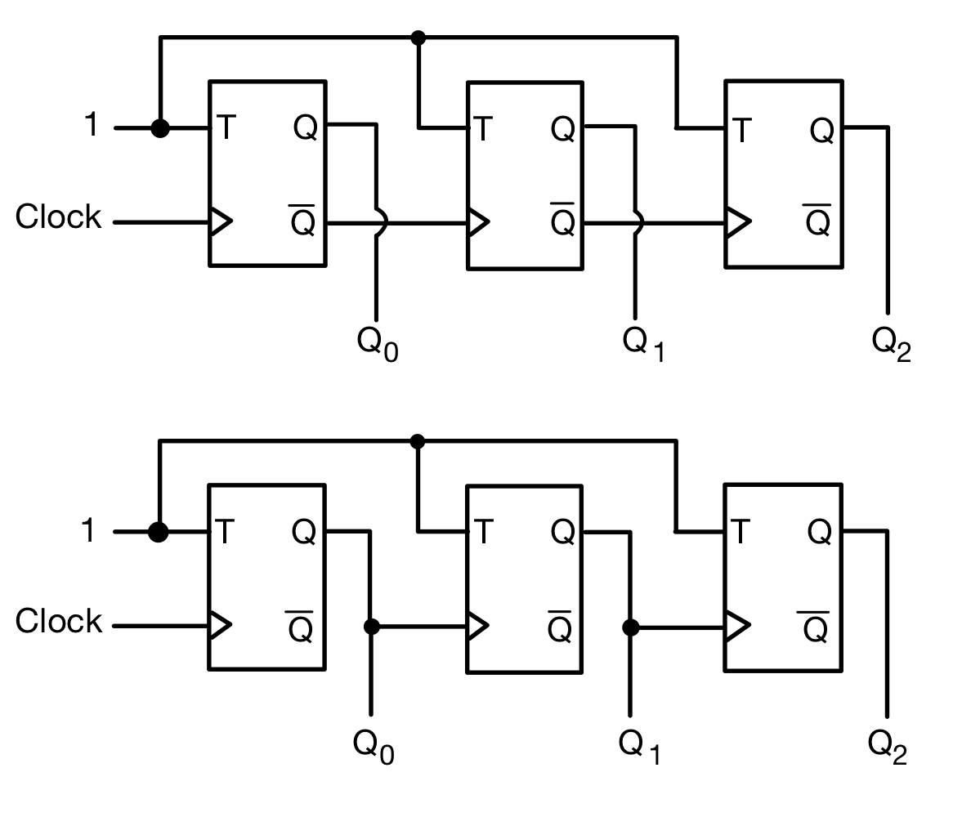

A: Asynchronous Up Counter A: Asynchronous Down Counter

_____________________________ _____________________________

2. Find out whether the horizontal 7-segment display, 157119S12801, uses a common anode or cathode (the datasheet can be found [here](https://www.digikey.com/en/products/detail/w%C3%BCrth-elektronik/157119S12801/14640744?s=N4IgTCBcDaIIwFYDsc4E4DKcwA4AMcIAugL5A)). Then, label all ten pins in the diagram below with the name/letter of the segment that they control or with the function that they perform.

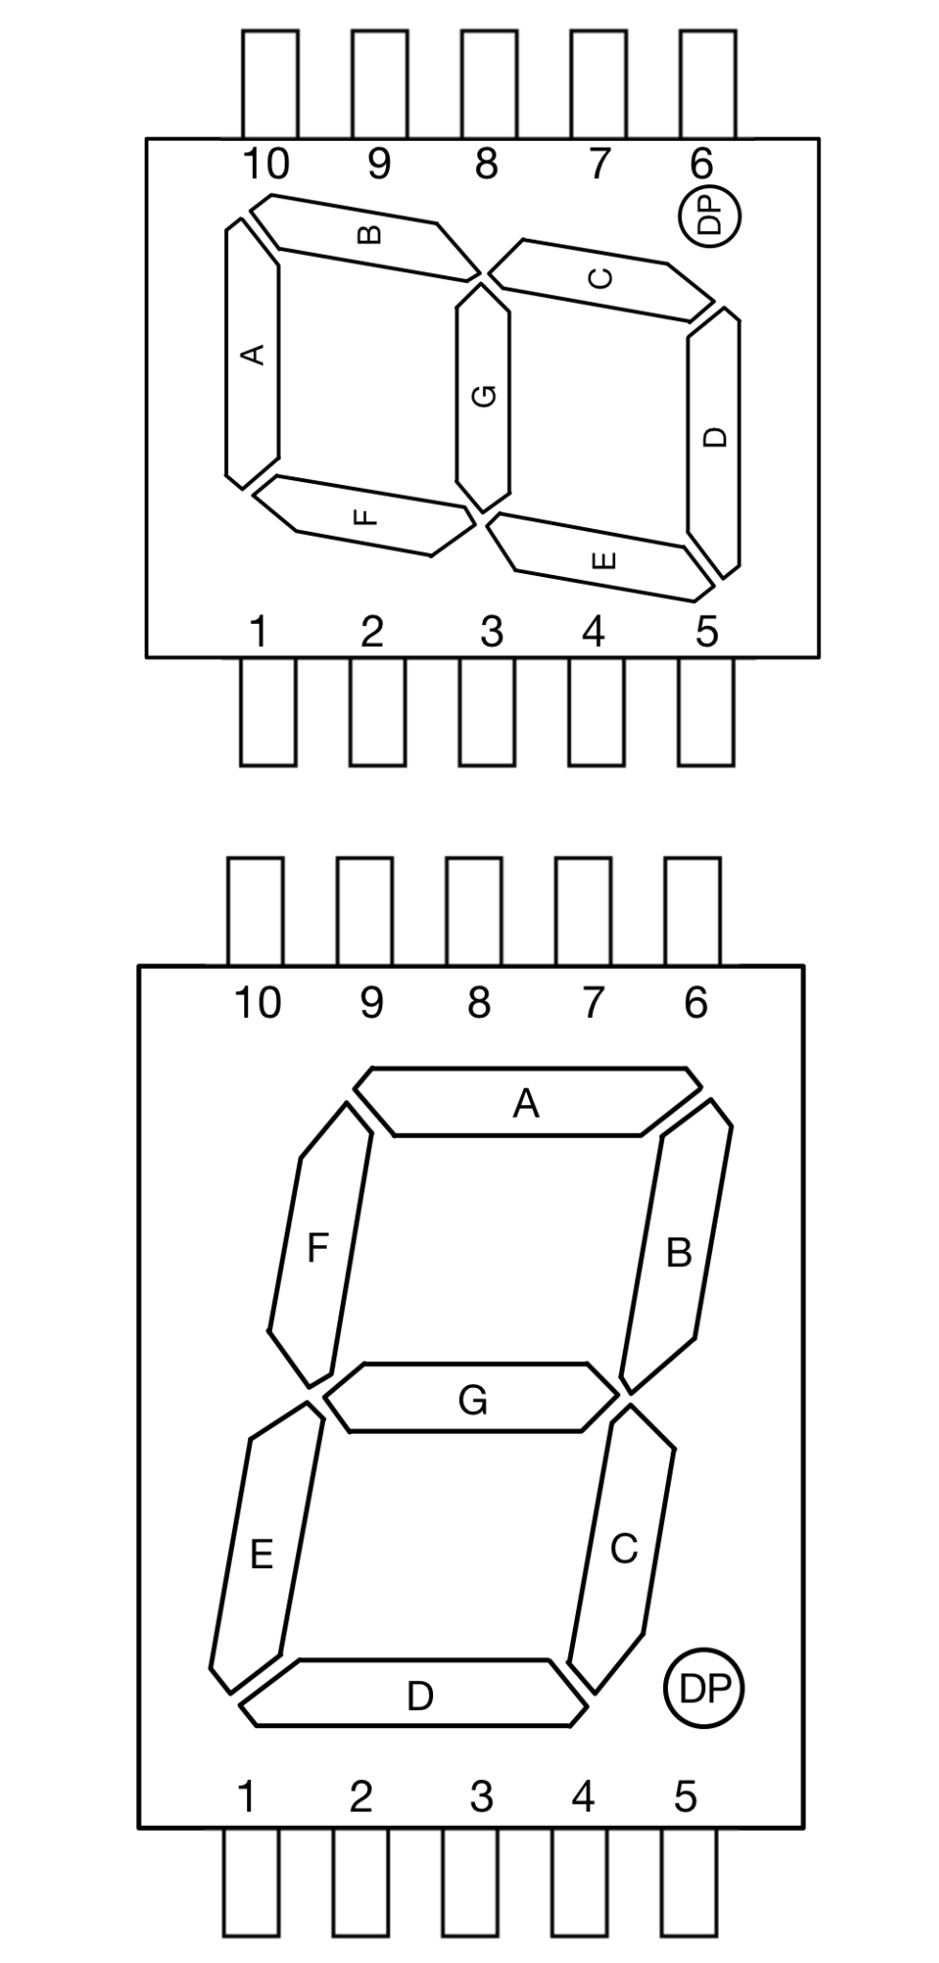

3. Repeat the task from question 2 above, but this time for the vertical 7-segment display LSHD-5601 (see the [datasheet](https://www.digikey.com/en/products/detail/liteon/LSHD-5601/560008?s=N4IgTCBcDaIIwDYAMBaOBWA7OlOByAIiALoC%2BQA)).



**Lab**

**4.4 Test the Display**

Demonstrate to the TA that the values 0111, 1000, 1011, 1111, and 0000 produce the expected results on the display when these binary numbers are entered with the DIP switch. (20 pts)

TA Initials:

**5.4**  **Test the Counter**

Write the counting sequence without debouncing. Is this sequence repeatable? Does it skip any numbers? Have the TA check your results before moving on. (20 pts)

Counting Sequence: TA Initials:

**6.1 Debounce a new Push Button**

Write the counting sequence with debouncing. Is this sequence repeatable? Does it skip any numbers? (20 pts)

Counting Sequence: TA Initials:

**6.2 Debounce the Original Button**

How many inverters are embedded in the Schmitt trigger based on the datasheet? Show the TA the results after debouncing the original push button. (20 pts)

Number of Inverters: TA Initials:

**7.0 Decade Counter**

Show the TA the output of the decade counter. (20 pts)

TA Initials: